* 1. **Write a Java program to display default value of all primitive data type of JAVA.**

**Aim:-** To write a Java program to display default value of all primitive data type of JAVA

**Program:-**

public class defaultvalues

{

static byte b;

static short s;

static int j;

static long l;

static float f;

static double d;

static char c;

static boolean bl;

public static void main (String[] args)

{

System.out.println("byte:"+b);

System.out.println("short:"+s);

System.out.println("int:"+j);

System.out.println("long:"+l);

System.out.println("float:"+f);

System.out.println("double:"+d);

System.out.println("char:"+c);

System.out.println("boolean:"+bl);

}

}

**Output:**

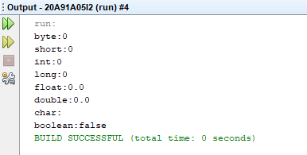

**1.2)Write a Java program to find the discriminant value D and find out the roots of the quadratic equation of theformax2+bx+c=0.**

**Aim:-** To w rite a Java program to find the discriminant value D and find out the roots of the quadratic equation of theformax2+bx+c=0

**Program:-**

public class quadraticequation

{

public static void main(String[] Strings)

{

double a=Double.parseDouble(Strings[0]);

double b=Double.parseDouble(Strings[1]);

double c=Double.parseDouble(Strings[2]);

double d=b *b -4.0 * a *c;

System.out.println("discriminent value:" +Math.pow(d,0.5));

if(Double.isNaN(d))

System.out.println("equation has no roots");

if(d>0.0)

{

double r1=(-b+Math.pow(d,0.5))/(2.0*a);

double r2=(-b-Math.pow(d,0.5))/(2.0*a);

System.out.println("the roots are"+r1+"and"+r2);

}

else if(d==0.0)

{

double r1=-b/(2.0*a);

System.out.println("the root is:"+r1);

}

else

{

System.out.println("roots are not real");

}

}

}

**Output:**

Arguments :1 5 4

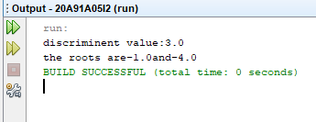

**1.3) Five Bikers Compete in a race such that they drive at a constant speed which may or may not be the same as the other. To qualify the race, the speed of a racer must be more than the average speed of all 5 racers. Take as input the speed of each racer and print back the speed of qualifying racers.**

**Aim:-**  To find the racers whose speed is greater than the average speed

**Program:-**

public class bikers

{

public static void main (String[] Strings)

{

double a=Double.parseDouble(Strings[0]);

double b=Double.parseDouble(Strings[1]);

double c=Double.parseDouble(Strings[2]);

double d=Double.parseDouble(Strings[3]);

double e=Double.parseDouble(Strings[4]);

double avg_speed=(a+b+c+d+e)/5;

System.out.println("the average speed for qualifying racers are:"+avg_speed);

if(a>avg_speed)

System.out.println("racer 1 is qualified with speed "+a+"which is more than avg speed"+avg_speed);

if(b>avg_speed)

System.out.println("racer 2 is qualified with speed "+b+"which is more than avg speed"+avg_speed);

if(c>avg_speed)

System.out.println("racer 3 is qualified with speed "+c+"which is more than avg speed"+avg_speed);

if(d>avg_speed)

System.out.println("racer 4 is qualified with speed "+d+"which is more than avg speed"+avg_speed);

if(e>avg_speed)

System.out.println("racer 5 is qualified with speed "+e+"which is more than avg speed"+avg_speed);

else

System.out.println("none of the racers qualify the race:");

}

}

**Output:**

Arguments:10 20 30 40 50

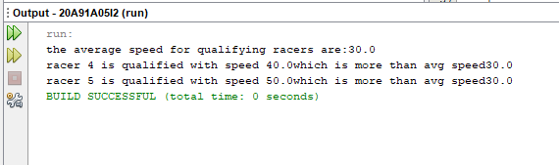

**2.1) Write a Java program to select all the prime numbers within the range of 1to100.**

**Aim:-** To write a Java program to select all the prime numbers within the range of 1to100

**Program:-**

public class primenumbers

{

public static void main(String[] args)

{

int ct=0,n=0,i=1,j=1;

while(n<25){

j=1;

ct=0;

while(j<=i){

if(i%j==0)

ct++;

j++;

}

if(ct==2){

System.out.printf("%d ",i);

n++;

}

i++;

}

}

}

**Output:**

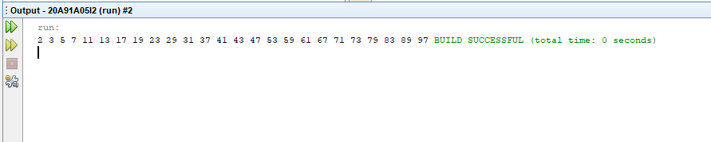

**2.2) Write a Java program to Find the sum of all even terms in the Fibonacci sequence up To the given range N.**

**Aim:-** To write a Java program to Find the sum of all even terms in the Fibonacci sequence up To the given range N

**Program:-**

import java.util.Scanner;

public class fibonacci_even

{

public static void main(String args[])

{

int f=0,s=1;

int t=0,sum=0;

int a[]=new int[100];

Scanner input=new Scanner(System.in);

a[0]=0;

a[1]=1;

System.out.println("enter rhe range for fibonacci series:");

int range=input.nextInt();

System.out.println("the fibonacci series is as follows:");

System.out.print(0);

System.out.print(" "+1);

for(int i=2;i<range;i++)

{

t=f+s;

System.out.print(" "+t);

a[i]=t;

f=s;

s=t;

}

for(int i=2;i<=range;i++)

{

if(i%2==0)

sum=sum+a[i];

}

System.out.println("\n"+"Sum of Even Terms in Fibonacci Series upto arange "+range+" is:"+sum);

}

}

}

**Output:**

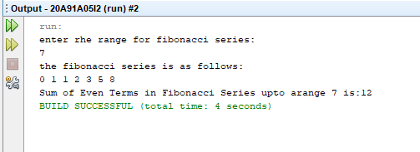

**2.3) Write a Java program to check whether a given number is Armstrong or not.**

**Aim:-** To write a Java program to check whether a given number is Armstrong or not.

**Program:-**

public class armstrong

{

public static void main (String[] args)

{

int number=1634,originalNumber,remainder,result=0,n=0;

originalNumber=number;

for(;originalNumber!=0;originalNumber/=10,++n);

originalNumber=number;

for(;originalNumber!=0;originalNumber/=10)

{

remainder=originalNumber%10;

result+=Math.pow(remainder, n);

}

if(result==number)

System.out.println(number +" is an armstrong number,");

else

System.out.println(number +" is not an armstrong number,");

}

}

**Output:**

